**Summary**

Certification Exam Link:

<https://www.lynda.com/SharePoint-tutorials/Cer-Prep-Sharepoim-2013-Microsoft-Offince-Specialist-77-419/453301-2.html>

**To down load SharePoint use:**

[**https://businessstore.microsoft.com/en-us/create-account/signup?offerid=B07A1127-DE83-4a6d-9F85-2C104BDAE8B4&dl=ENTERPRISEPACK&ispolaris=1&culture=en-US&country=US&ali=1&products=cfq7ttc0k59j:0009**](https://businessstore.microsoft.com/en-us/create-account/signup?offerid=B07A1127-DE83-4a6d-9F85-2C104BDAE8B4&dl=ENTERPRISEPACK&ispolaris=1&culture=en-US&country=US&ali=1&products=cfq7ttc0k59j:0009)

**1.Site collection**

**=>Office.com**

**=>Admin**

**=>SharePoint**

**=>**<https://eyos2011-admin.sharepoint.com/_layouts/15/online/SiteCollections.aspx>

<https://eyos2011.sharepoint.com/sites/Demo/SitePages/Home.aspx>

=>Private site collection

=>Put title/Fill everything/

=>ok->referesh

**1.1.Creating New site collection:**

* site collection->New->Private site collection->Put title

**1.2.Creating Subsite collection:**

**Site content->”New SubSite” at the bottom of the page->the fill the popup**

**2. Edit Page**

**2.1. Page => Edit=>Edit source=>down one step the XML note=>ok=>then write**

**. Checkout->to keep d/t dev. Work when the work at the some time.**

**2.2.Edititing the top line/Ribbon**

Add: Bring Facebook URL->Click Edit->Link->Write name->past URL->Save

Delete: Edite->(X) sign next to Facebook

**2.3.Edititing the Left line/Quick launch**

**3.Newsfeed**

**=>Write the note=>post**

**4.Site Logo**

**=>setting=>site setting=>Logo=>From computer->Ok**

**5. Navigation Element**

**=>setting=>site setting=> Navigation Element =>**

**6. (v4). Add an App**

**=>setting=>site content=>add an app=>custom List/Document Library**

**Or**

**=>setting=>Site collection=> custom List/Document Library**

**7.Creating/uploading Documnt**

* Docmunt=>+ New /Uploaded document=>Browese =>Select file=>Open=>Ok

**8.Create A List and Library⬄same to an app**

* 1. **Create a List: eg**

**=>setting=>Site collection=>Add an app=>Custom List=>Write the name of List=>create**

**7.1.1. Add column:**

Open List=> List at the top=>add column=>

* 1. **Library: eg**

**=>setting=>Site collection=>Add an app=>Document Library=>Write the name of Library=>create**

**7.3.(v6).Delete a List and a Library:**

**List:**

**=>site collection=>contact=>List=>List setting=>delete. The same to Library**

**9. (v5). Edit the Name of List and Library**

**9.1. Edit the Name of List:**

**Click on the Name of List=>List=>List settings=>List Name description and**

**Navigation => then edit the name of the list=>then save**

**Eg. Edit “StudentList” to “Student List”**

**9.2. Edit the Name of Library:**

**Click on the Name of Library=>Library=>Library settings=>Library Name description**

**and Navigation=>then edit the name of the library=>then save**

**10.(v7). Create Calander and add event:**

**Calander:**

**At home page click site collection=>add an app=>calader=>give name(TeaCalander) =>the click create**

**event:**

**click on created calander=>at the top clict “Event”=>New Event=>**

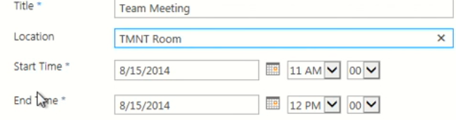

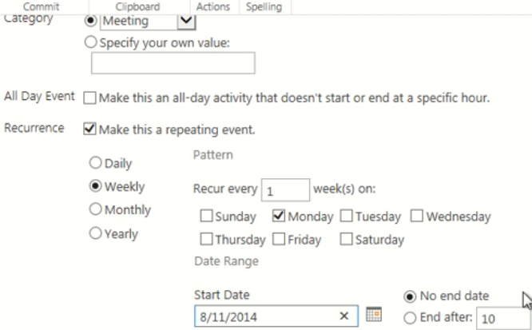

**Then save it**

**11.(V8).creating acalander overlay**

**Open acalander you created=>at the top click calander=>calander overlay=>New calander=>**

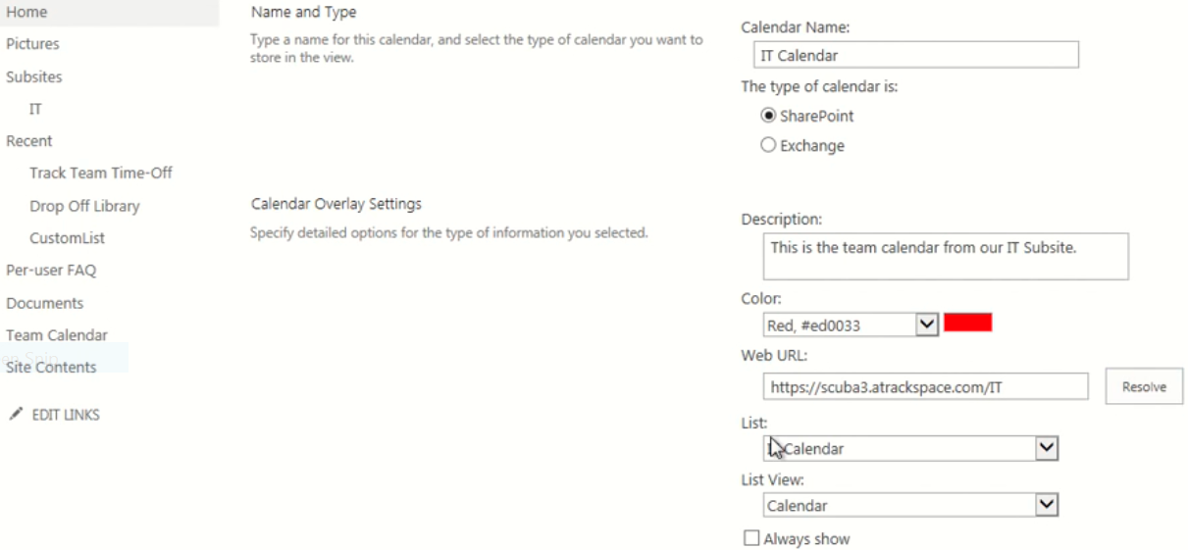

**Resolve =>Ok=>ok**

**11.(V9). How to create a column.**

Open your library/List as you like. In my case Document Library

Open your library=>Library at the top=>create clumn=>give a name(Purpose)=>choice=>

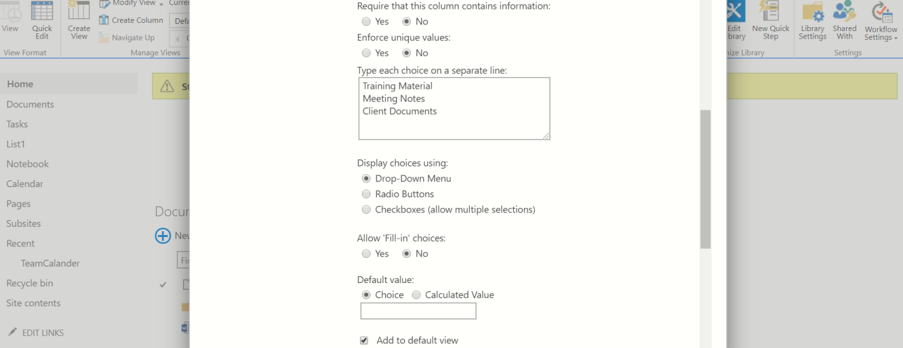

Then **OK**

**12.(V10). How to modify an existing column.**

Open your library/List as you like. In my case Document Library

Open your Library at the top=>Library settings=>Purpose=> Add **Internet** from my choice=>Ok

13.(V11). **How to create a folder**

Open your library/List as you like. In my case Document Library:

Document=>Open **Files** at the top=>New folder=>Give name(folder)=>save

14.(V12). **How to upload a document.**

**Case1:**

Open your library/List as you like. In my case Document Library:

Document=>Open Files at the top=>Upload=>Browse

**Case2**:

Open Document=>then Uploaded the doc by drag and drop

**15.(V13). How to create a task list and add a new task.**

**To create**

**Site content=>add an app=>Tasks=>gine Name(Team Tasks)=>create**

**To add new Task**

open the created task=>New task =>Then save.

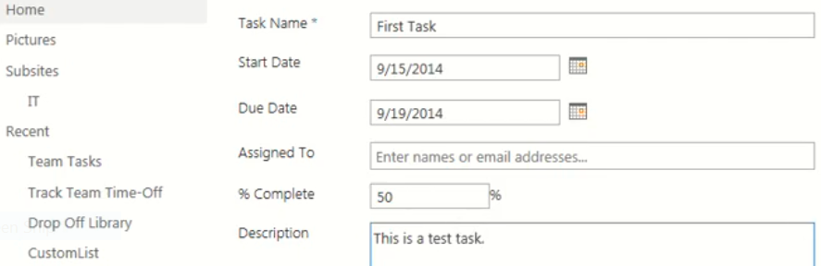

16.(V14). **How to create a subtask.**

**Open “Team Task”=>Ellipse next to task=>create subtask=>**

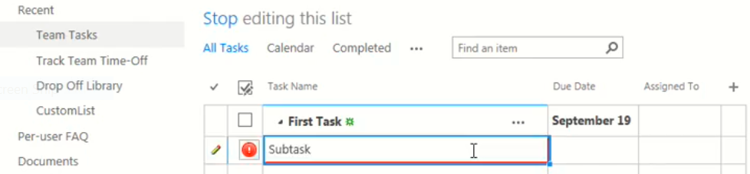

Enter=>then Stope editing

17.(V15). **How to create a Site Column. Site Column is used to restrict the list and library**

Setting=>Site Settings=>site column=>create=>give name=>active “choice ….”=>

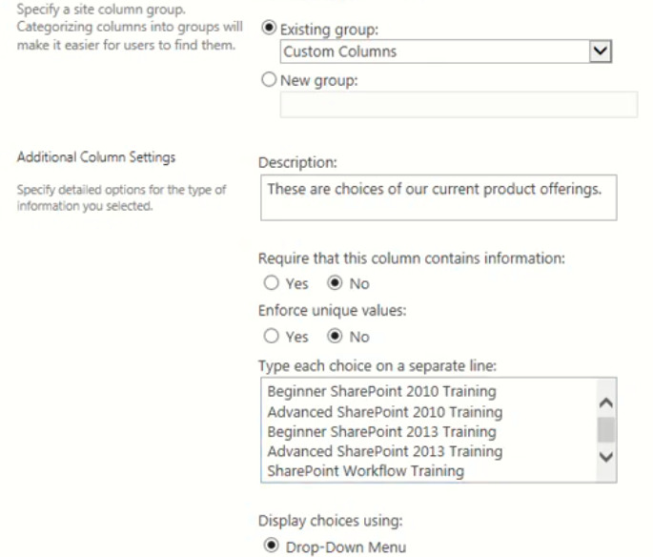

**then Ok**

**18.(V16). How to create a view.**

Open your library/List as you like. In my case Document Library:

Library=>Library settings=>at the bottom of the page “**view->create**”=>standard view=>give Name(Reviewed)=>

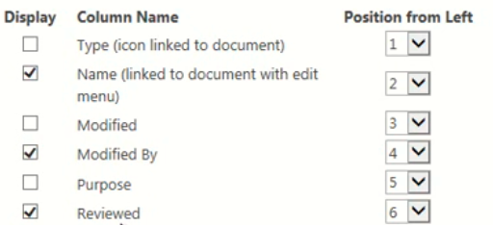

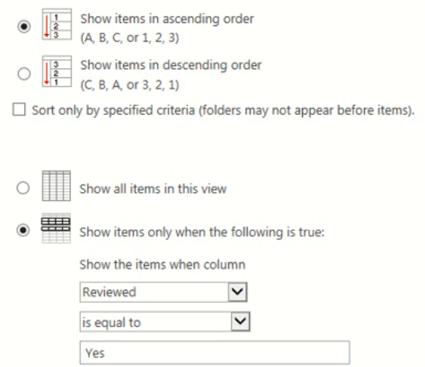

**Ok**

**19.(V17). How to edit a view.**

Document Library=>Library settings=>at the bottom of the page “**view->Reviewed**”=>

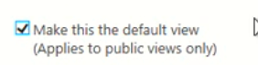and **active description-> then ok**

**20.(V18). How to create a promoted links list (PARTI**

**Site content=>add an app=>promoted Link=>give name(promotedIcon)=>create**